Exercise 1: The Search Bar vs AI Test

Objective
To compare Google Search and Gemini for solving the same problem.

Steps Performed
- Searched "Gmail organisation tips" on Google Search.
- Opened Gemini and entered the prompt:
I am completely overwhelmed by my Gmail inbox. I receive 80 or more emails a day, mostly from clients and suppliers. How can I build a practical system to manage this better?
- Compared the responses from Google Search and Gemini.

Observations
- Gemini provided personalized advice based on the context.
- Google Search mainly showed links and web pages.
- Gemini gave practical step-by-step suggestions instead of requiring me to search multiple websites.

Outcome
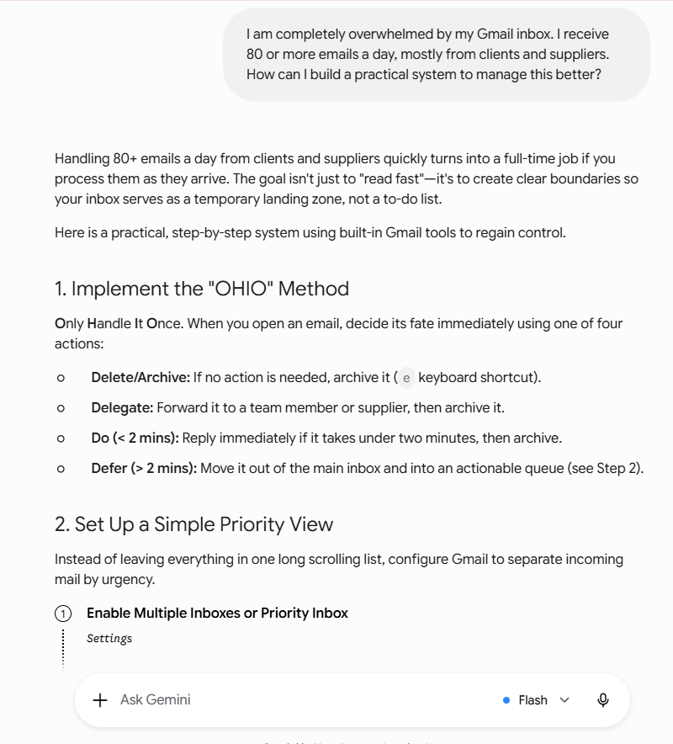
Gemini provided a more personalized and actionable response than Google Search.
📸 Screenshots:
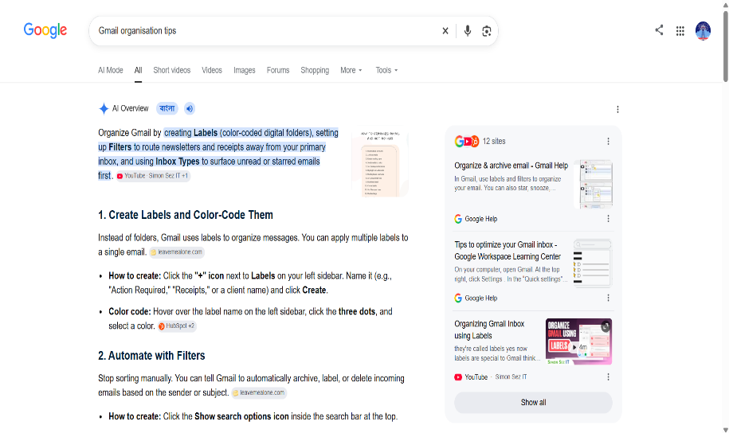

Exercise 2: Configure the AI Brain Before Using It

Objective
To configure Gemini for personalized responses.

Steps Performed
- Opened Gemini Settings.
- Checked for Custom Instructions and Memory.
- The Custom Instructions feature was not available in my Gemini account.

Outcome
I could not complete this exercise because the Custom Instructions feature was unavailable in my account.

Exercise 3: Voice Input vs Typed Input

Objective
To compare typed input and voice input in Gemini.

Steps Performed
- Typed:
Productivity tips for remote work.
- Used the microphone icon and spoke:
I have been working from home for two years. My biggest challenges are staying focused during long video calls, avoiding unhealthy snacking, and mentally switching off from work at the end of the day. What practical strategies should I try?
- Compared both responses.

Outcome
The voice prompt produced a more detailed and personalized response because it included more context.
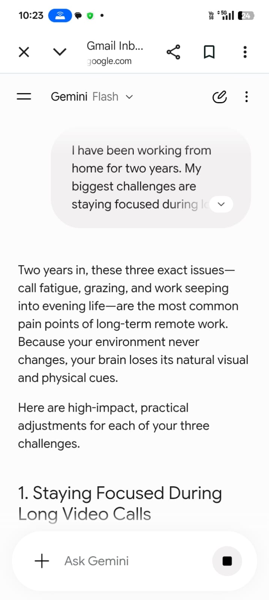
📸 Screenshot:
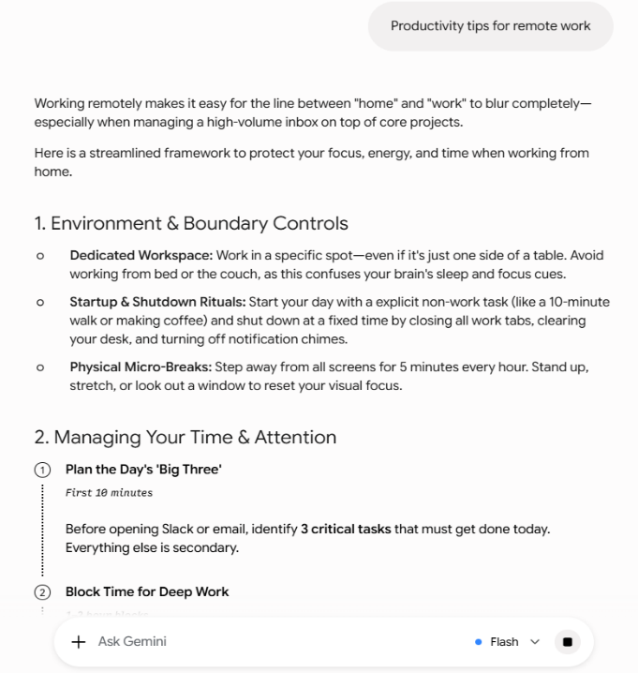

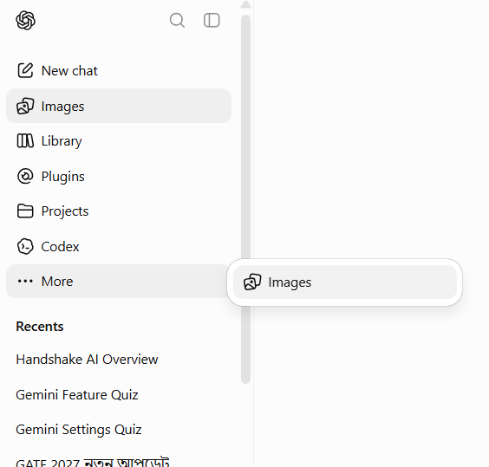
Exercise 4: Build and Iterate a Task-Specific Gem

Objective
To create a task-specific Gem.

Steps Performed
- Opened Gemini.
- Checked for the Gems feature.
- The Gems feature was not available in my Gemini account.

Outcome
I could not complete this exercise because the Gems feature was unavailable.
📸 Screenshot:

Exercise 5: NotebookLM Research Integration

Steps
- Open notebooklm.google.com
- Create New Notebook
- Upload ৩টা
- Ask:
  - What are the 3 most important themes across these documents?
  - What is the biggest challenge discussed in these documents?
  - Write a summary.
- Summary Gemini
Write a 300-word executive briefing.

Outcome
NotebookLM successfully analyzed multiple documents and generated a structured summary. Gemini then converted the summary into a professional executive briefing.
📸 Screenshots:
- NotebookLM notebook
- Generated summary
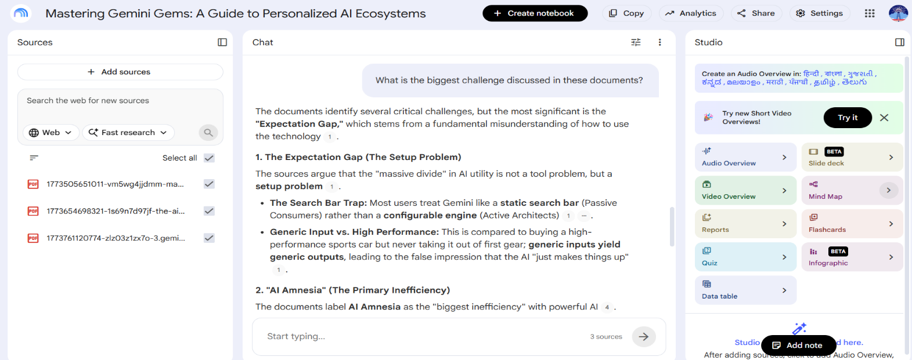
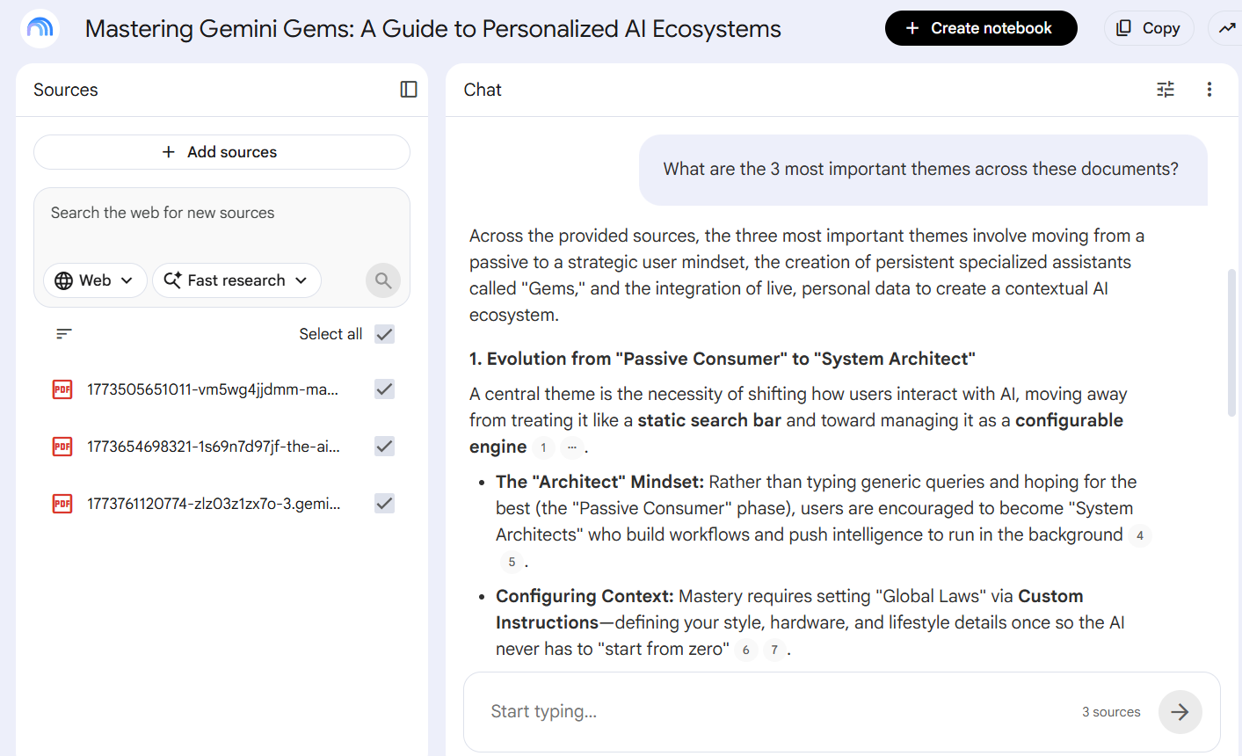
- Gemini executive briefing
